

Requirement & Design Specification

Affiliate Network

**Nền tảng tiếp thị liên kết giữa các công ty và đối tác**

– Ho Chi Minh Campus, Feb 2025 –

# Record of Changes

| **Version** | **Date** | **A*, M, D** | **In charge** | **Change Description** |
| --- | --- | --- | --- | --- |
| V1.0 | 12/2/2025 | A | Thư, Hoàn | Write Context Diagram and Screen Flow |
| V1.0 | 12/2/2025 | A | Sơn, Khôi | Business Rule and User Story |
| V1.0 | 12/2/2025 | A | Nhất | Design ERD Diagram |
|  |  |  |  |  |
|  |  |  |  |  |
|  |  |  |  |  |
|  |  |  |  |  |
|  |  |  |  |  |
|  |  |  |  |  |
|  |  |  |  |  |
|  |  |  |  |  |
|  |  |  |  |  |

*A - Added M - Modified D - Deleted

Contents

Record of Changes 2

I. Overview 4

1. Team Members: 4

2. User Requirements 4

1.1 Actors 4

3. Overall Functionalities 4

2.1 Screens Flow 4

2.2: Functional requirement: 6

2.3: Non-Functional requirement: 7

4. System High Level Design: 7

3.1 ERD Diagram: 7

II. System Diagram 9

III. Context Diagram: 9

IV. Business Rules 10

1. Data Requirements 11

2. System Architecture 11

3. Security Considerations 12

V. User Case Diagram: 13

VI. User Story: 13

1. Advertiser 13

1.1 Campaign Management 13

1.2 Campaign Performance Tracking 14

1.3 Fraud Detection & Prevention 14

2. Publisher 14

2.1 Campaign Discovery & Selection 14

2.2 Earnings & Performance Tracking 14

2.3 Fraud Defense & Compliance 15

3. Administrator 15

3.1 Platform Moderation & Security 15

4. Platform-Wide Features 15

4.1 Payments & Transactions 15

4.2 Dashboards & Reports 16

# I. Overview

## 1. Team Members:

| **STT** | **Full name** | **Student code** | **Email** |
| --- | --- | --- | --- |
| 1 | Dương Minh Nhất | SE182236 | NhatDMSE182236@fpt.edu.vn |
| 2 | Phạm Đăng Khôi | SE170462 | KhoiPDSE170462@fpt.edu.vn |
| 3 | Vũ Ngọc Hoàn | SE170449 | HoanVNSE170449@fpt.edu.vn |
| 4 | Phạm Nguyễn Đan Thư | SE170446 | ThuPNDSE170446@fpt.edu.vn |
| 5 | Vũ Thanh Sơn | SE171604 | SonVTSE171604@fpt.edu.vn |

## 2. User Requirements

### 1.1 Actors

| **#** | **Actor** | **Description** |
| --- | --- | --- |
| 1 | Advertiser | Post about the products they want to advertise, when pushing a product, fields such as product price, product name, image, place of manufacture,... will appear then press push it and a post will appear on the home page |
| 2 | Publisher | Marketplace searches for campaigns that match their audience.  Filter by campaign type, payment model (CPC, CPA, CPI, CPS), and advertiser rating. |
| 3 | End User | Enter ads, view products and buy products. |
| 4 | Administrator | Review and approve content and campaigns,investigate and analyze fraudulent activity,tax reporting and compliance monitoring,monitor third-party integrations and API usage. |
| 5 | Platform-Wide | User tracking with tracking pixels, URL parameters, cookies, Fraud detection with AI/ML, Automated payment processing with secure encryption, Advertiser, publisher dashboard with KPIs and insightsSimple onboarding, 24/7 support, help center. |

## 3. Overall Functionalities

### 2.1 Screens Flow

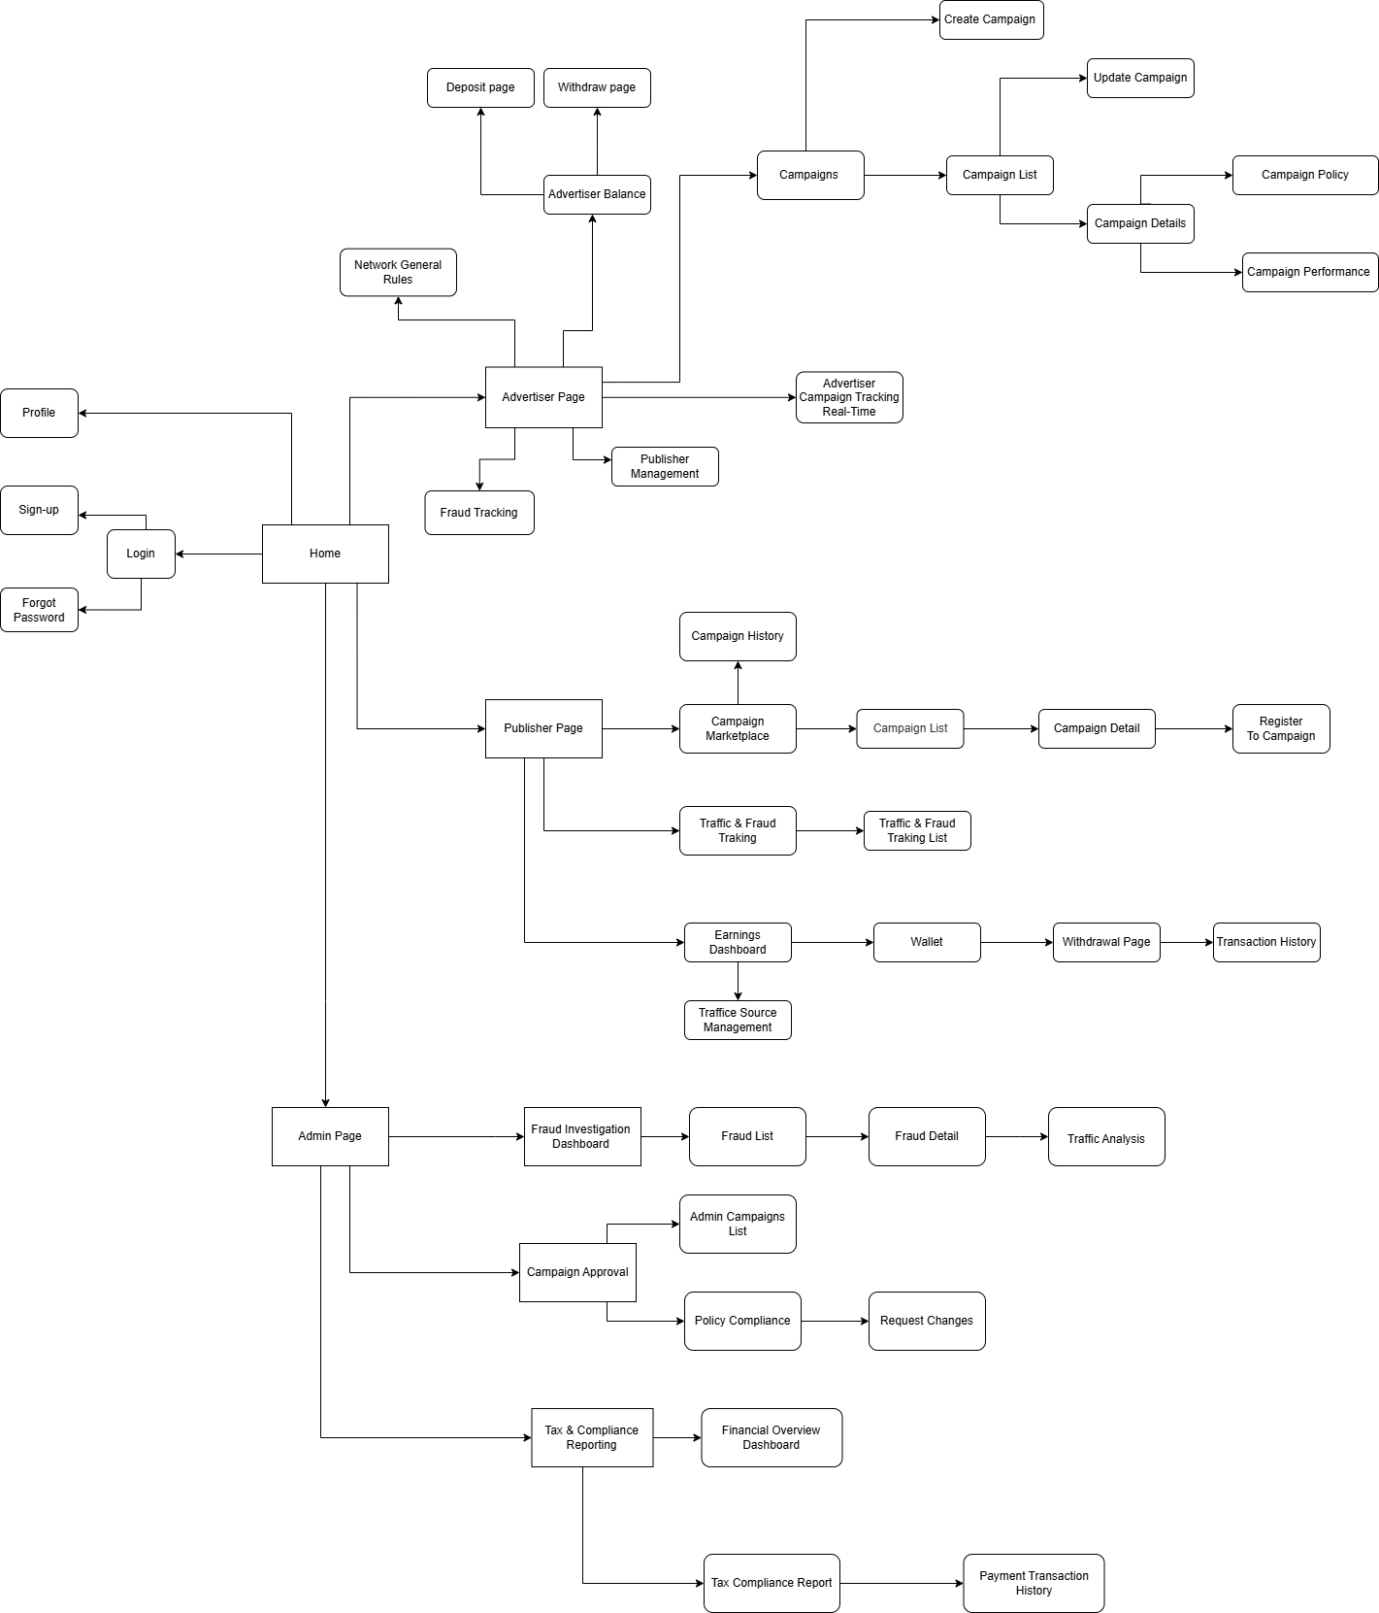

Link: [Screen Flow](https://drive.google.com/file/d/1LwVmHV5lHjQ6lmMcwiqmSYRYr6F3z4Ff/view?usp=sharing)

### 2.2: Functional requirement:

* **Advertiser features:**
* **Campaign Creation and Management:**
  + Interface to create campaigns with details such as audience targeting (e.g., location, device, demographics).
  + Ability to set budgets and campaign objectives.
* **Real-Time Campaign Tracking:**
  + Monitor impressions, clicks, conversions, and overall ROI in real-time.
  + Access historical data for trend analysis and optimization.
* **Fraud Monitoring:**
  + Alerts for suspicious activities such as abnormal traffic spikes or invalid conversions.
  + Tools to block fraudulent traffic sources dynamically.
* **Reporting and Insights:**
  + Generate visualized reports with customizable metrics.
  + Export reports in formats like CSV or PDF.
* **Publisher features:**
* **Campaign Discovery:**
  + A searchable marketplace to find campaigns relevant to their audience.
  + Filters for campaign type, payout models (CPC, CPA, CPI, CPS,...), and advertiser ratings.
* **Earnings Tracking:**
  + Real-time dashboard displaying earnings, traffic sources, and conversion rates.
  + Tools to analyze traffic quality and performance.
* **Traffic Source Management:** Monitor, label, and optimize different traffic sources for performance and quality.
* **Referral Bonuses:** Extra-income for bringing other publishers to the platform.
* **Earnings Milestone Tracker:** Track progress toward achieving goals with motivational prompts.
* **Affiliate URL tools:** Tools help publishers generate tracking urls, shorten urls, optimize urls.
* **Fraud Defense:**
  + System to review and respond to fraud accusations with clear evidence.
  + Access to fraud prevention tips and tools to maintain traffic quality.
* **Platform-Wide features:**
* **Traffic Tracking System:**
  + Implementation of tracking pixels, URL parameters, and cookies for user action monitoring.
  + Centralized data storage in databases with high scalability.
* **Fraud Detection System**
* **Payment System**
  + Automated payment processing with secure encryption.
* **Dashboards and Reports:**
  + Centralized dashboards for advertisers and publishers with KPIs and traffic insights.
  + Customizable layouts for different user needs.
* **User Experience and Support:**
  + Simplified onboarding process for new users with tutorials.
  + A help center and 24/7 live support for issue resolution.
* **Administrator features:**
* **Fraud Investigation Dashboard:** A dedicated dashboard to investigate flagged activities with detailed insights into traffic anomalies.
* **Content Moderation Tools:** Review and approve campaigns to ensure compliance with platform policies and legal regulations.
* **Tax and Compliance Reporting**
* **API Usage Monitoring:** Track third-party integrations and monitor API usage for security and optimization.

### 2.3: Non-Functional requirement:

* **Security:**
* Secure registration, authentication, and data encryption.
* **Data integrity:**
* Ensure data accuracy and consistency, with regular backups and interaction logs.
* **Maintainability:**
* Well-structured, documented codebase for easy maintenance and updates.
* **Reliability:**
* Support session recovery and reliable appointment scheduling.

#### 

## 4. System High Level Design:

### 3.1 ERD Diagram:

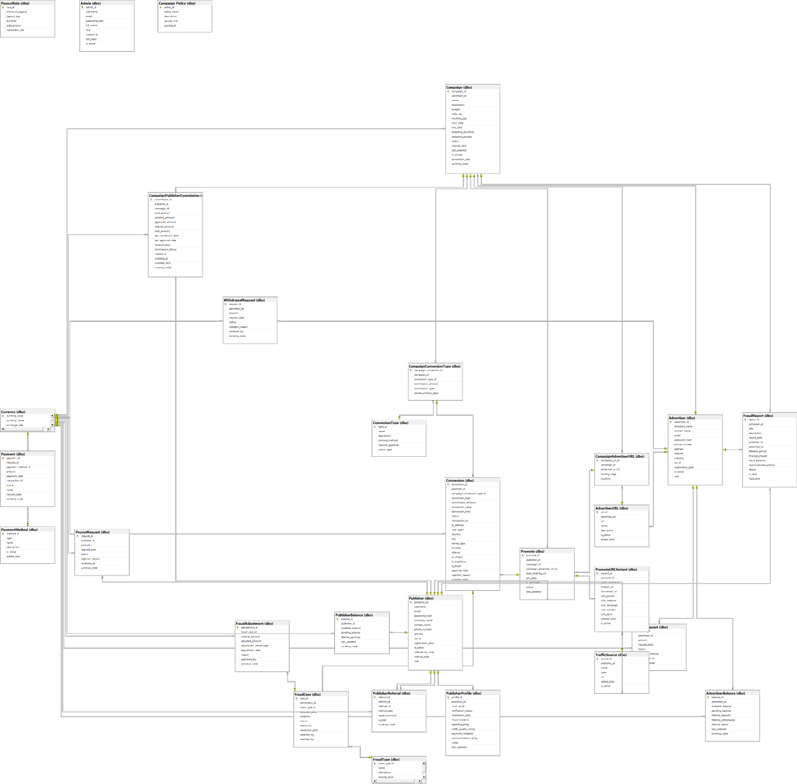

*Link:* [*ER Diagram*](https://drive.google.com/file/d/1qcvW-3GUroEq0PTCO4X57YBZlo414iCQ/view?usp=drive_link)

# II. System Diagram

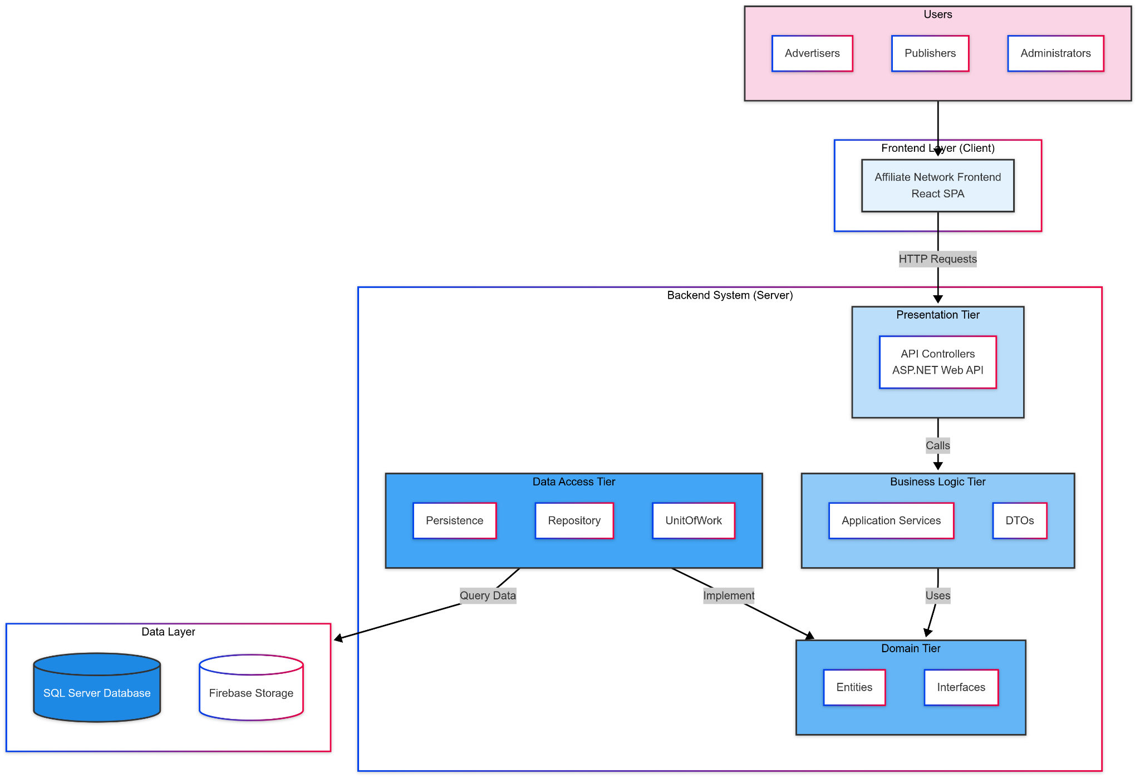

Link: [System Diagram](https://drive.google.com/file/d/1hgexJ4dX324rRqmcqJthsJDVbjvprbEn/view?usp=drive_link)

# **III. Context Diagram:**

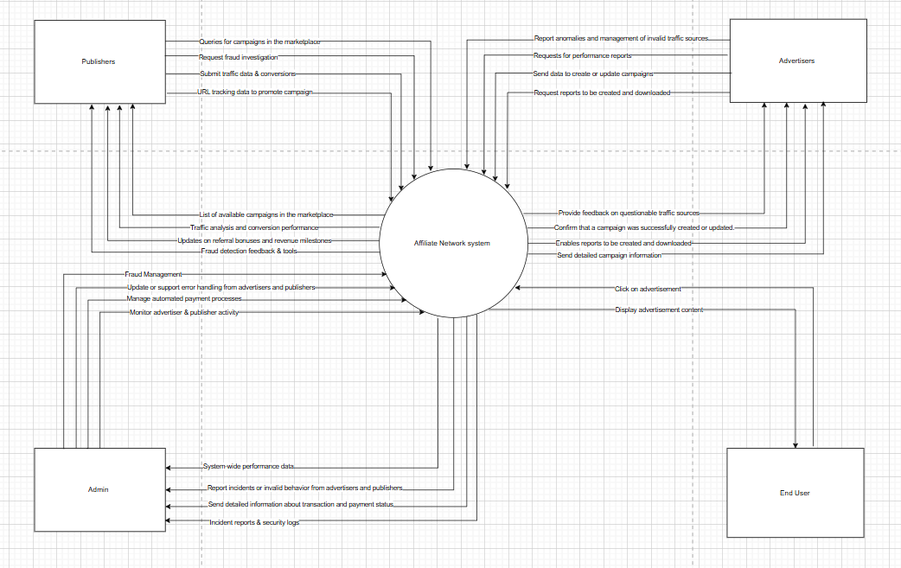

Link: [Context](https://drive.google.com/file/d/1_0VGFkdEXyhkh9P0ypWCbS4Lr7NmBoAg/view?usp=sharing)

# IV. Deployment Diagram

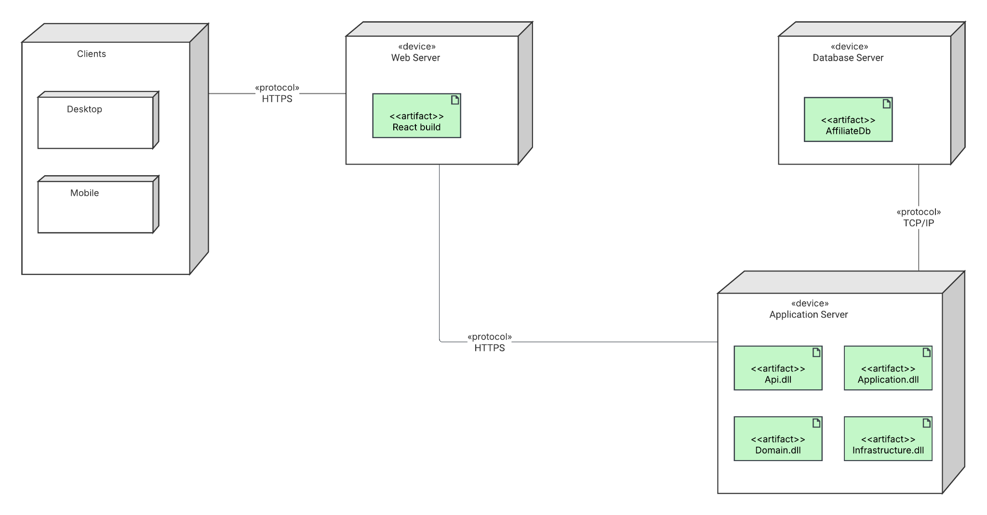

Deployment Diagram 1, Link:

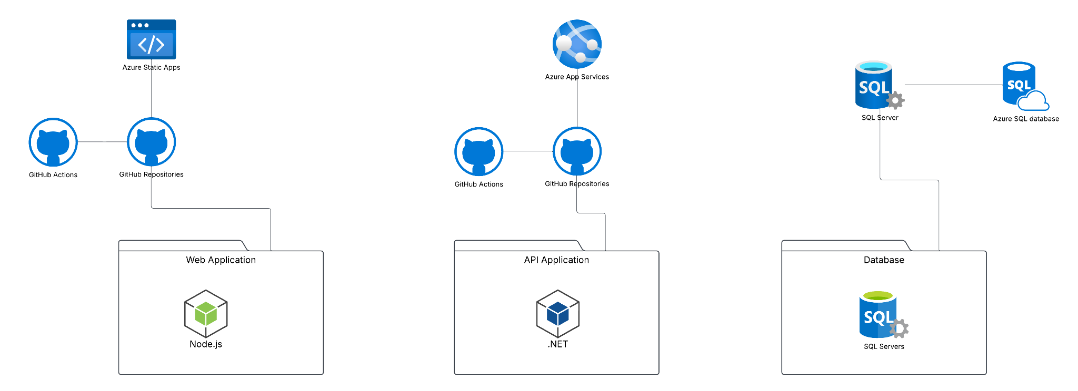

Deployment Diagram 2

# V. Component Diagram

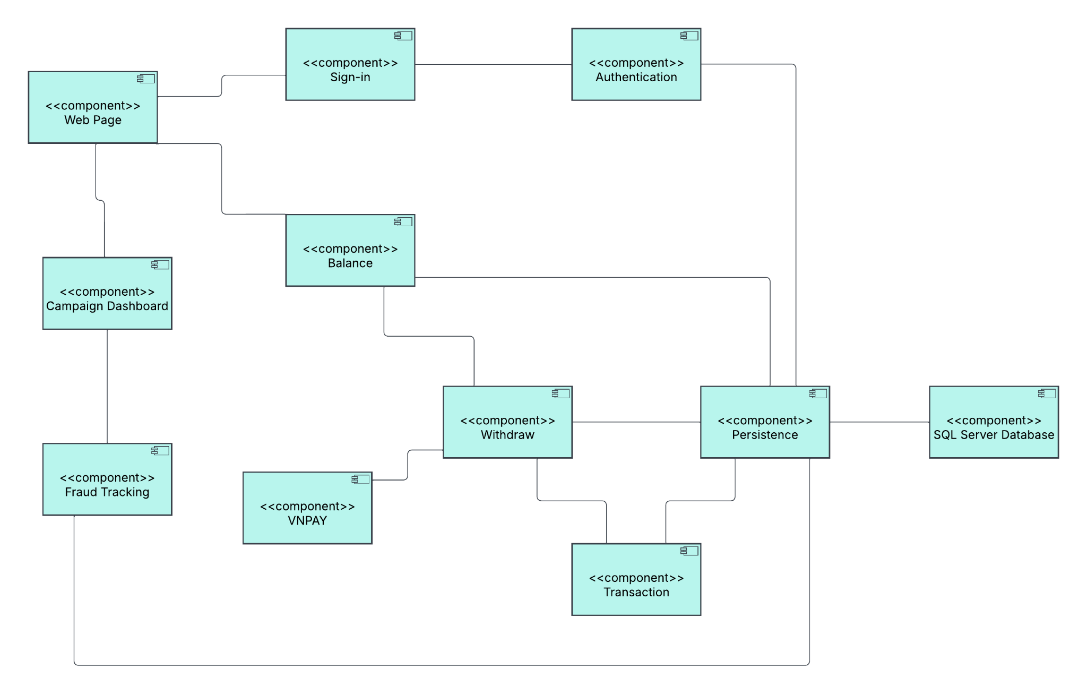

# VI. Package Diagram

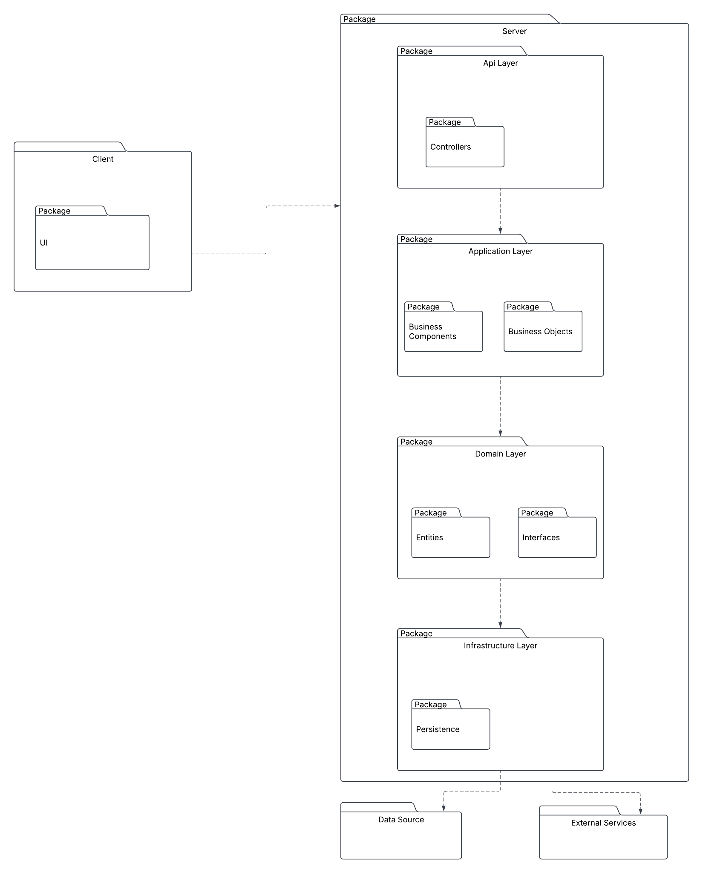

# VI. Sequence Diagram

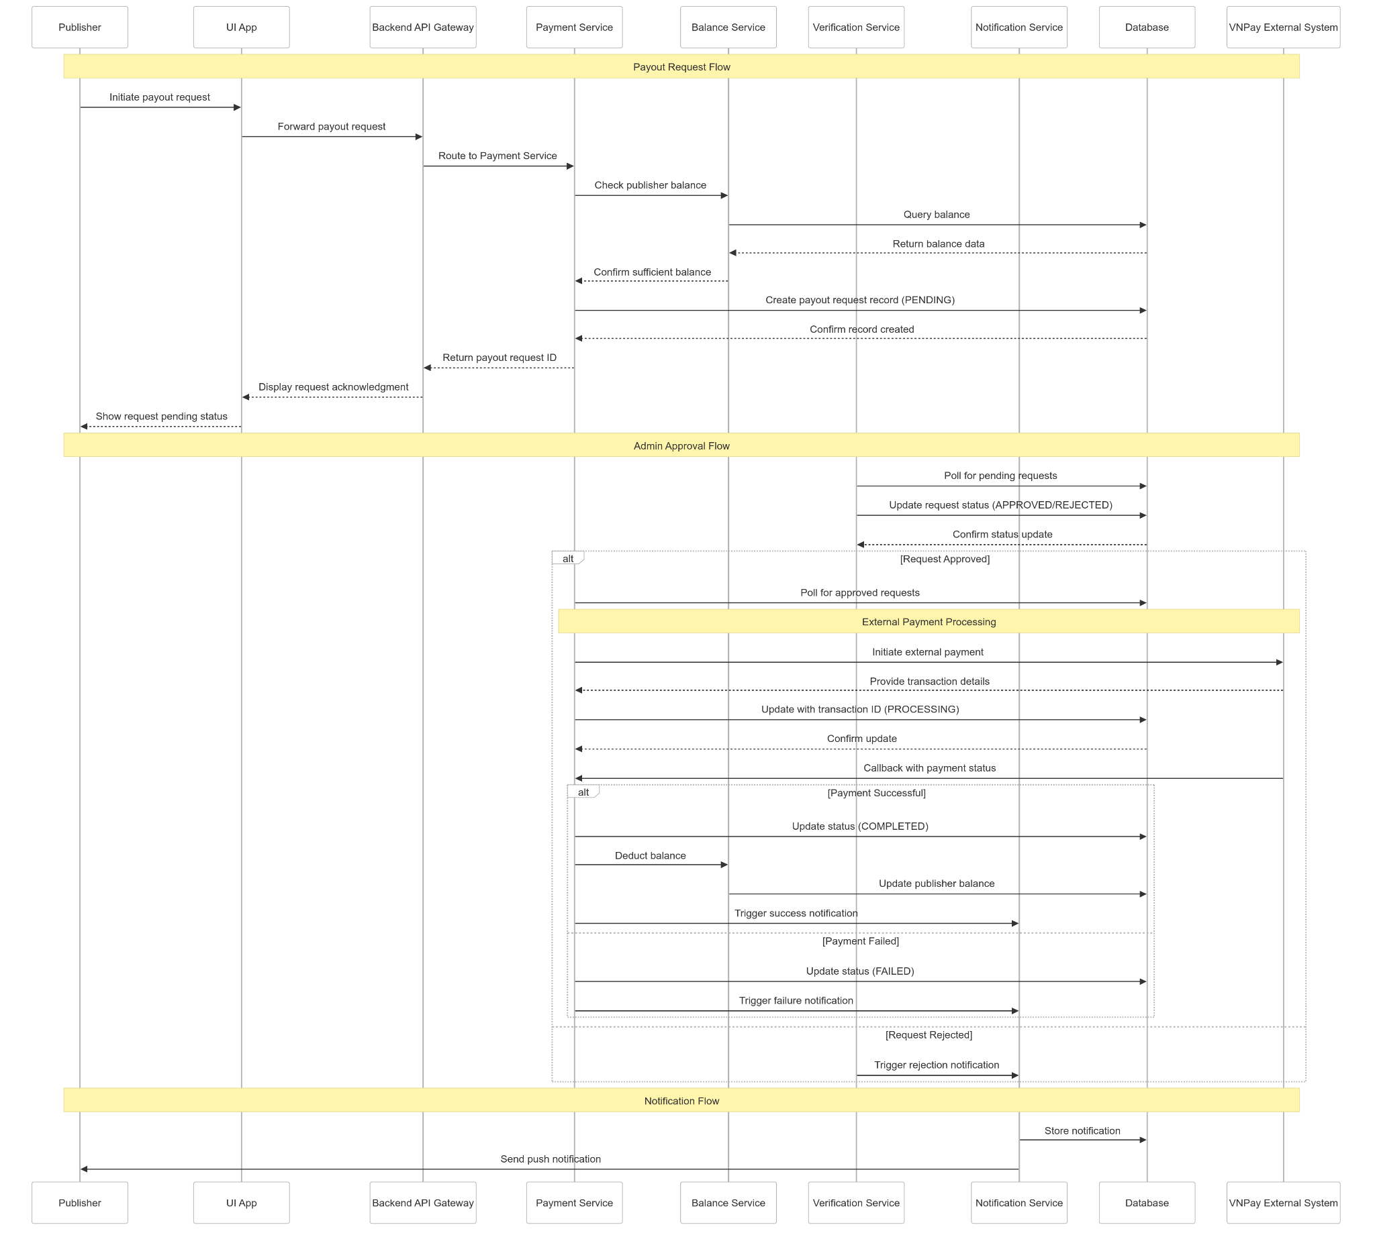

Link: [Payment Sequence Diagram](https://drive.google.com/file/d/13EIjztcLM0yvEfTpHMko2Tgoj7TEElcS/view?usp=drive_link)

# IV. Business Rules

| **ID** | **Rule Definition** |
| --- | --- |
| **BR-01** | **Campaign budgets must be set and cannot exceed the advertiser’s available balance.** |
| **BR-02** | **Fraudulent traffic sources must be automatically blocked by the system.** |
| **BR-03** | **Publishers cannot promote campaigns that have expired or been suspended.** |
| **BR-04** | **Campaigns must be reviewed and approved by the admin before being listed in the marketplace.** |
| **BR-05** | **Advertisers must maintain a minimum account balance for active campaigns.** |
| **BR-06** | **Publishers must comply with the platform’s fraud prevention guidelines to maintain eligibility for earnings.** |
| **BR-07** | **Only admins have permission to edit active campaigns at the request of the advertiser.** |
| **BR-08** | **System automatically blocks publishers who get more than two fraud reports.** |
| **BR-09** | **Each campaign is associated with a unique tracking URL for performance monitoring.** |
| **BR-10** | **The platform stores historical campaign performance data for trend analysis.** |
| **BR-11** | **Fraud detection logs are stored for future reference and dispute resolution.** |
| **BR-12** | **Advertisers and publishers have access to a performance dashboard with key metrics.** |
| **BR-13** | **Payment transactions are recorded and audited for compliance and security purposes.** |
| **BR-14** | **Admins have full control over campaign approvals, fraud investigation, and compliance enforcement.** |
| **BR-15** | **Advertisers and publishers can generate detailed reports in CSV or PDF formats.** |
| **BR-16** | **Campaign ROI is calculated based on conversion rates, cost per acquisition (CPA), and other KPIs.** |
| **BR-17** | **Admin must review and approve any significant campaign changes** |
| **BR-18** | **Maximum of 3 clicks per unique user per day for each campaign** |
| **BR-19** | **Commission rates must be clearly defined before campaign activation** |
| **BR-20** | **API access suspended after 5 failed authentication attempts** |

### **1. Data Requirements**

#### **Requirement Analysis**

1. **Customer Information:**
   * **Data Needed:** Customer name, contact information (phone number, email), address for delivery, purchase history (including items purchased and dates), loyalty program membership status.
   * **Purpose:** To maintain a database of customer profiles for personalized marketing, order processing, and customer service.
2. **Product Details:**
   * **Data Needed:** Product name, description, category (e.g., rings, necklaces, bracelets), SKU (Stock Keeping Unit), barcode, supplier information, cost price, selling price, current inventory levels.
   * **Purpose:** To manage inventory effectively, track product performance, and facilitate accurate sales transactions.
3. **Pricing Data:**
   * **Data Needed:** Pricing rules (e.g., markup percentages, discount structures), promotional pricing details, tax rates applicable to jewelry items.
   * **Purpose:** To ensure consistency in pricing across products, apply promotions correctly, and calculate total transaction amounts accurately.
4. **Sales Transactions:**
   * **Data Needed:** Date and time of sale, items purchased (including quantities), payment method, total amount paid, salesperson ID, transaction ID.
   * **Purpose:** To record and track all sales activities, analyze sales trends, and generate financial reports.
5. **Loyalty Program Records:**
   * **Data Needed:** Points accumulated by customers, redemption history, eligibility criteria for earning points, rewards offered.
   * **Purpose:** To manage customer loyalty programs, incentivize repeat purchases, and enhance customer retention.

### **2. System Architecture**

#### **Architecture Design**

1. **Hardware Requirements:**
   * **Components:** TV screens for displaying gold prices and promotional messages, POS (Point of Sale) terminals at each counter for transaction processing.
   * **Purpose:** To provide a user-friendly interface for customers and staff, support sales operations, and enhance customer engagement through promotional displays.
2. **Software Components:**
   * **Database Management System (DBMS):** Central database to store and manage customer data, product details, pricing information, and transaction records securely.
   * **Sales Management Software:** Application to handle sales transactions, inventory management, pricing calculations, and loyalty program tracking.
   * **Integration Points:**
     + **Payment Gateways:** Integration with payment processors to facilitate secure and efficient payment transactions.
     + **Inventory Management:** Integration to synchronize inventory levels and automate stock replenishment based on sales data and trends.
3. **Integration with External Systems:**
   * **Purpose:** To streamline operations, ensure real-time data updates across systems, and provide seamless customer service and transaction experiences.

### **3. Security Considerations**

#### **Security Analysis**

1. **Data Protection:**
   * **Measures:** Encryption of sensitive data (e.g., customer information, transaction records) both in transit and at rest.
   * **Purpose:** To prevent unauthorized access and data breaches, ensuring compliance with data protection regulations (e.g., GDPR, CCPA).
2. **Access Control:**
   * **Implementation:** Role-based access control (RBAC) to restrict system access based on user roles (e.g., sales staff, managers).
   * **Purpose:** To limit access to sensitive information and functionalities only to authorized personnel, minimizing the risk of internal threats.
3. **Secure Transactions:**
   * **Protocols:** Use of secure communication protocols (e.g., HTTPS) for online transactions and payment processing.
   * **Purpose:** To safeguard customer payment information and ensure secure financial transactions.
4. **Regular Audits and Monitoring:**
   * **Practices:** Regular security audits, vulnerability assessments, and monitoring of system logs for suspicious activities.
   * **Purpose:** To proactively identify and mitigate security risks, maintaining the integrity and reliability of the jewelry sales management system.

# 

# 

# 

# V. User Case Diagram:

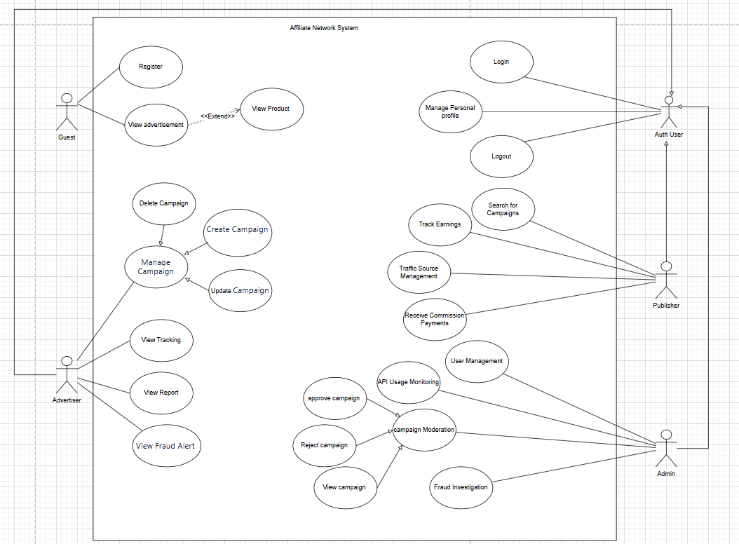

# VI. User Story:

## **1. Advertiser**

### **1.1 Campaign Management**

**ID:** ADV-01  
**As an** advertiser,  
**I want to** create an advertising campaign with criteria such as budget, objectives, target audience, and payment model,  
**So that** I can promote my products/services to the right audience.

**ID:** ADV-02  
**As an** advertiser,  
**I want to** edit or pause my active campaigns,  
**So that** I can adjust my marketing strategies based on performance.

**ID:** ADV-03  
**As an** advertiser,  
**I want to** set different payout models (CPC, CPA, CPS, etc.) for my campaigns,  
**So that** I can optimize costs and maximize conversions.

### **1.2 Campaign Performance Tracking**

**ID:** ADV-04  
**As an** advertiser,  
**I want to** monitor real-time data on impressions, clicks, conversions, and ROI,  
**So that** I can analyze performance and make data-driven decisions.

**ID:** ADV-05  
**As an** advertiser,  
**I want to** generate and export reports on campaign performance in CSV or PDF format,  
**So that** I can review and share insights with my marketing team.

### **1.3 Fraud Detection & Prevention**

**ID:** ADV-06  
**As an** advertiser,  
**I want to** receive alerts when suspicious traffic activity is detected,  
**So that** I can take immediate action to protect my ad spend.

**ID:** ADV-07  
**As an** advertiser,  
**I want to** block fraudulent traffic sources dynamically,  
**So that** I can ensure my budget is spent on genuine conversions.

## **2. Publisher**

### **2.1 Campaign Discovery & Selection**

**ID:** PUB-01  
**As a** publisher,  
**I want to** browse and filter available campaigns based on payout models, advertiser ratings, and categories,  
**So that** I can choose the best campaigns to promote to my audience.

**ID:** PUB-02  
**As a** publisher,  
**I want to** generate tracking URLs for campaigns I promote,  
**So that** I can accurately track and report conversions.

### **2.2 Earnings & Performance Tracking**

**ID:** PUB-03  
**As a** publisher,  
**I want to** view my real-time earnings, traffic sources, and conversion rates,  
**So that** I can optimize my strategies for higher revenue.

**ID:** PUB-04  
**As a** publisher,  
**I want to** receive important notifications about my earnings progress,  
**So that** I stay motivated to reach my financial goals.

### **2.3 Fraud Defense & Compliance**

**ID:** PUB-05  
**As a** publisher,  
**I want to** review and respond to fraud report with clear evidence,  
**So that** I can maintain my credibility on the platform.

**ID:** PUB-06  
**As a** publisher,  
**I want to** access fraud prevention tips and tools,  
**So that** I can ensure my traffic sources comply with platform policies.

## **3. Administrator**

### **3.1 Platform Moderation & Security**

**ID:** ADMIN-01  
**As an** administrator,  
**I want to** review and approve all campaigns before they go live,  
**So that** I can ensure compliance with platform policies and legal regulations.

**ID:** ADMIN-02  
**As an** administrator,  
**I want to** investigate flagged traffic anomalies using a dedicated fraud dashboard,  
**So that** I can take action against fraudulent activities.

## **4. Platform-Wide Features**

### **4.1 Payments & Transactions**

**ID:** PAY-01  
**As a** publisher,  
**I want to** withdraw my earnings once I reach the minimum payout threshold,  
**So that** I can receive my payments securely and on time.

**ID:** PAY-02  
**As an** advertiser,  
**I want to** deposit funds securely into my account,  
**So that** I can run multiple ad campaigns without interruptions.

### **4.2 Dashboards & Reports**

**ID:** DASH-01  
**As an** advertiser or publisher,  
**I want to** customize my dashboard layout to focus on key performance indicators,  
**So that** I can track the most relevant metrics efficiently.

**ID:** DASH-02  
**As an** administrator,  
**I want to** generate reports on platform-wide statistics, including sales revenue, user activity, and fraud cases,  
**So that** I can optimize platform performance and security.